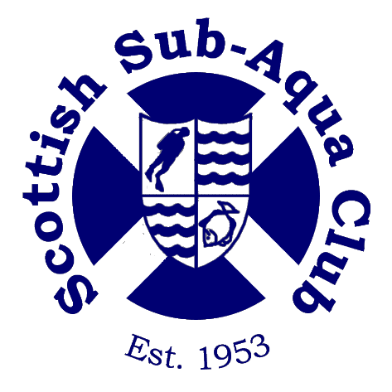
Scottish Sub Aqua Club

Privacy Notice

Author: Harper Macleod / E. Ewan
Date: 03.18

Document Information

Version # | 0.2
Version  Date | 03.18
Version  Status | Final.

What we need

Scottish Sub Aqua Club is a not -for -profit organisation run by volunteers, providing membership and training in the sport of SCUBA diving, specifically designed for Scottish waters.

Scottish Sub Aqua Club Sport Governing Body will be a “controller” of the personal information that you provide to us through the website registration form or on a paper application, unless otherwise stated.

When you register as a member of Scottish Sub Aqua Club or renew your membership (including if you are registering or renewing on behalf of a child under the age of 18), we will ask you for the following personal information:

- contact details – name, address, email address, and date of birth;

- membership criteria / category - ordinary, joint, family, junior, student, family, associate.
- equality information – disability (if any), ethnic group, gender identity.
- PVG membership or update ( if involved in training juniors in Group 2 or 3 branches)

Why we need your personal information – contractual purposes

We need to collect our members’ personal information so that we can manage your membership.
We will use our members’ personal information to:
- provide you with core member services, including insurance, PVG checks;
- set up your online membership account and administer your account online; and
    - send you membership communications by post or email in relation to essential membership
      - services, including but not limited to, membership renewals and information on membership
          - benefits, general meeting notices, and
- to establish members medical fitness to undertake the sport of SCUBA diving,

If you do not provide us with all of the personal information that we need to collect then this may affect our ability to offer the above membership services and benefits.

Why we need your personal information – legitimate purposes

We also process our members’ personal information in pursuit of our legitimate interests to:
- promote and encourage participation in the sport of SCUBA Diving by sending members’ communications and booking information for upcoming events. Our events may be filmed or photographed and your personal information may also be used in images captured from our events, which we use for promotional, education and development purposes;
- monitor and develop participation in the sport of SCUBA diving by monitoring membership numbers and engagement and inviting our members to participate in surveys for researching and development purposes;
- develop and maintain our members’ qualifications, including sending email communications to members to inform you of upcoming courses, renewal requirements and verify that you have completed any mandatory training and PVG / child protection requirements; and
- respond to and communicate with, members regarding your questions, comments, support needs or complaints, concerns or allegations in relation to the sport. We will use your personal information to investigate your complaint, to suspend membership, take disciplinary action where appropriate.

- If your PVG certificate is not clear, we will have a legitimate interest to collect references and any other applicable information to allow us to consider whether or not you can volunteer in a regulated role with children and/or vulnerable adults.

Where we process your personal information in pursuit of our legitimate interests, you have the right to object to us using your personal information for the above purposes. If you wish to object to any of the above processing, please contact us on hq@scotsac.com. If we agree and comply with your objection, this may affect our ability to undertake the tasks above for the benefit of you as a member.

Why we need your personal information – legal obligations

We are under a legal obligation to process certain personal information relating to our members for the purposes of complying with our obligations under:
- the Companies Act 2006 to maintain a register of our members, which includes our members’ name, address, the date they were admitted to membership and the date on which they ceased to be our member, and hold general meetings, including issuing notices and voting arrangements
- our sportscotland regulatory requirements to report on the size, achievements and profile of our members; and
- the Equality Act 2010, which requires us to process personal information to make reasonable adjustments where necessary.
- Group 2 & 3 branches. We will need to collect personal information relating to criminal convictions or alleged commission of criminal offences where you are required to complete a PVG check under the Protection of Vulnerable Groups (Scotland) Act 2007. This information will include your PVG certificate number, PVG membership number, date of issue and any relevant information in relation to your membership of the PVG Scheme.
- If your PVG certificate is not clear, we will have a legitimate interest to collect references and any other applicable information to allow us to consider whether or not you can volunteer in a regulated role with children and/or vulnerable adults.

Why we need your personal information – equality monitoring requirements

We are required to use our members’ personal information relating to your disability (if any), ethnic group, religious belief, gender identity and sexual orientation for equality monitoring purposes as required by sportscotland.
We will process such personal information through aggregated and anonymised reports to identify and keep under review the existence or absence of equality of opportunity or treatment between groups of people within the same categories to promote or maintain equality within our sport.

Other uses of your personal information
We may ask you if we can process your personal information for additional purposes. Where we do so, we will provide you with an additional privacy notice with information on how we will use your information for these additional purposes.

Who we share your personal information with
If your personal information is included in any images or videos taken by us at our events, we may share this with Sport Scotland and/ or other diving organisations for promotional and/or journalistic purposes.
We may be required to share personal information with statutory or regulatory authorities and organisations to comply with statutory obligations.
Such organisations include the Health & Safety Executive, Disclosure Scotland, and Police Scotland for the purposes of safeguarding children.
We may also share personal information with our professional and legal advisors for the purposes of taking advice.
We share your personal information with your chosen branch to maintain your membership at branch level.
In the event that we do share personal information with external third parties, we will only share such personal information strictly required for the specific purposes and take reasonable steps to ensure that recipients shall only process the disclosed personal information in accordance with those purposes.

How we protect your personal information
Your personal information is stored on our electronic filing system and our servers based in the UK, and is accessed by our staff and Board members for the purposes set out above.

How long we keep your personal information
We will only keep your personal information for as long as necessary to provide you with membership services. Unless you ask us not to, we will review and possibly delete your personal information where you have not renewed your membership with us for five years.
We will keep certain personal information of members for longer in order to confirm your identity, when you were a member of Scottish Sub Aqua Club and for how long. We need to do this to comply with the Companies Act 2006, which requires us to keep a register of members or in the event of a claim against Scottish Sub Aqua Club.

Your rights

You can exercise any of the following rights by writing to us at hq@scotsac.com
Your rights in relation to your personal information are:
- you have a right to request access to the personal information that we hold about you by making a “subject access request”;
- if you believe that any of your personal information is inaccurate or incomplete, you have a right to request that we correct or complete your personal information;
- you have a right to request that we restrict the processing of your personal information for specific purposes; and
- if you wish us to delete your personal information, you may request that we do so.

Any requests received by Scottish Sub Aqua Club will be considered under applicable data protection legislation. If you remain dissatisfied, you have a right to raise a complaint with the Information Commissioner’s Office at www.ico.org.uk

